**INTERNATIONAL INDIAN SCHOOL AL-JUBAIL**

**MIDTERM REVISION - 2023**

**CLASS : X ENGLISH**

**SECTION A READING**

* 1. 1. **Read the text carefully and answer the questions:**
  2. **1.**As the family finally sets off from home after many arguments, there is a moment of lull as the car takes off. "Alright, so where are we going for dinner now?" asks the one at the driving wheel. What follows is a chaos, as multiple voices make as many suggestions.
  3. 2.By the time, order is restored and a decision is arrived at, tempers have risen, feelings injured and there is at least one person grumbling.
  4. 3.Twenty years ago, you would step out of home, decision of meal and venue already made with no arguments or opposition and everybody looked forward to the meal with equal enthusiasm. The decision was made by the head of the family and the others fell in line. Today every member of the family has a say in every decision which also promotes a sense of togetherness and bonding.
  5. 4.We empower our kids to take their own decisions from a very early age. We ask them the cuisine they prefer, the movie they want to see, the holiday they wish to go on and the subjects they wish to study.

5.It's a closely connected world out there, where children consult and guide each other. A parent’s well meaning advice can sound like nothing more than unnecessary preaching. How then do we reach our children through all the conflicting views and make the voice of reason be heard? Children today question choices and prefer to go with the flow.

6. What then is the best path to take? I would say the most important thing one can do is to listen. Listen to your children and their silences. Ensure that you keep some time aside for them, insist that they share their stories with you. Step into their world. It is not as complicated as it sounds; just a daily half an hour of the quality time would do the trick.

* + 1. 1.According to the passage, who said, "so, where are we going for dinner now?"
    2. a. narrator
    3. b. one at the steering
    4. c. one of the passengers
    5. d. one of the guests
    6. 2.Twenty years ago, according to the passage, decisions were ________

a. unanimous, with no argument

* + 1. b. made by the children
    2. c. taken by the head of the family
    3. d. not taken by elders

3.The passage concludes that in modern times, children are ________ to take their own decision from a very early age.

1. a. forbidden
2. b. trained
3. c. not given permission
4. d. allowed
5. 4.Choose the antonym as given in para 6 of this passage.
6. 

5.Twenty years ago, the decision was made by the head of the family and the others fell in line. How the decision are taken now a days?

* 1. 6.What is the message conveyed by this passage? Write any two points
  2. 1. _____________________________________________
  3. 2. _____________________________________________
  4. 7.After arriving at a decision almost everyone is ­­­­­­________ in the family mentioned above.
  5. a. happy
  6. b. excited
  7. c. hurt
  8. d. elated
  9. 8.In modern times, the say each family member in decision making points towards ________ in the family

a. grudges

* 1. b. perfect bonding
  2. c. individual opinions
  3. d. none of these
  4. 9.The writer used word "hurt" in para 2. What is the synonyms of hurt as used in this paragraph.
  5. 10.The word which means the same as a style or method of cooking in para 4 is ________.
  6. a. gourmet
  7. b. cuisine
  8. c. gastric
  9. d. science
  10. 2. **Read the text carefully and answer the questions:**
  11. 1.The Measles Resurgence Autism spectrum disorders (ASD) are a range of psychological conditions characterised by abnormalities in social interaction, behaviour, interests, and communication. The five forms of ASD include Classical autism, Asperger syndrome, Pervasive Developmental Disorder, Rett syndrome, and Childhood Disintegrative Disorder. Although the number of reported cases of ASD have experienced a dramatic increase in the past 25 years, the majority of doctors agree that this increase is due to changes in diagnostic practices and advances in the understanding of psychiatric health.
  12. 2.While there is no general consensus among medical professionals about the underlying causes of ASD, theories range from genetic inheritance to environmental factors. One of the most controversial theories to have emerged in recent times is the hypothesis that ASD could be caused by the MMR vaccine, which is an immunization against measles, mumps, 1960". The vaccine is a mixture of three live viruses and is administered via injection to children when they are one year old. By the late 1990's, this vaccination had led to the near-eradication of measles in countries that employed widespread inoculation. However, a combination of spurious scientific data and alarmist media attention led to an entirely preventable resurgence in measles cases in the early 21st century.

3.The first claims of a connection between the MMR vaccine and autism were made in 1998, when an article in The Lancet a respected British medical journal, reported on eight cases of autism that could possibly be traced back to the administration of an MMR vaccine. The parents of the children in this study contended that the symptoms of autism in their children developed within days of vaccination. During a press conference, Andrew Wakefield, one of the doctors to stop giving combined MMR vaccines, instead advocating for individual inoculations against measles, mumps, and rubella.

4. Following the publication of this article, Wakefield published several follow-up papers that further questioned the safety of the MMR vaccine. An onslaught of media coverage then began. Parents appeared on television sharing anecdotal evidence linking their child's inoculation to the onset of ASD. The popular press quickly seized upon this story: in 2002, over 1200 articles were written about the link between MMR vaccines and ASD. Less than 30% of these articles mentioned that an overwhelming amount of scientific evidence suggested that these vaccinations were completely safe.

* 1. 1.The purpose of parents appearing on the television sharing anecdotal evidence was ________.
  2. 2.Select the option that is true for the two statements given below.
  3. (1) According to a study, it is found that the cause behind ASD in children is increasing stress and anxiety at atender age.
  4. (2) The advancement in diagnostic techniques by doctors had proven great to decrease the number of ASDcases.
  5. a. (1) is the result of (2).
  6. b. (1) is the reason for (2).
  7. c. (1) is true and (2) is false
  8. d. Both (1) and (2) are false
  9. 3.State the meaning of the statement "The popular press quickly seized upon this story."

4.According to the doctors, the number of reported cases of ASD have experienced a dramatic increase in the past25 years. It was because of ________.

* 1. 5.Select the option listing what the given sentence refers to.
  2. The symptoms of ASD did NOT include:
  3. (1) abnormalities in social interaction
  4. (2) high fever
  5. (3) bipolar behavior
  6. (4) unusual interests
  7. (5) Abnormal communication
  8. a. (1), (2) and (5)
  9. b. (2) and (3)
  10. c. (4) and (5)
  11. d. (1), (3) and (5)

**6**.The MMR vaccine contained three live viruses. (True/false)

* 1. 7.The story of MMR vaccines and ASD relation got attention proving the power of ________.
  2. 8.Which of the following options suggest that the safety of the vaccines had no great evidence as such?
  3. a. The parents of the children in this study contended that the symptoms of autism in their children developed within days of vaccination.
  4. b. Wakefield published several follow up papers that further questioned the safety of the MMR vaccine.
  5. c. Parents appeared on television sharing anecdotal evidence linking their child's inoculation to the onset of ASD.
  6. d. Less than 30% of these articles mentioned that an overwhelming amount of scientific evidence suggested that these vaccinations were completely safe.
  7. 9.The MMR vaccine was first developed in the 1950's. (True/false)
  8. 10.Complete the given analogy correctly with a word from the passage
  9. Dangerous : safe :: retreat: ________
  10. **SECTION B GRAMMAR**
  11. 1. According to the NASA astronaut Neil Armstrong, the aliens ________ a base on the Moon
  12. a) is having
  13. b) have
  14. c) has
  15. d) are having
  16. 2. Read the conversation between a doctor and his patient. Complete the sentence by reporting the patient’s reply correctly.
  17. Doctor: How do you feel now?
  18. Patient: Slightly better.
  19. The doctor, while trying to figure out his patient’s ailment, asked how he felt then, to which, the patient affirmed________.
  20. 3. Fill in the blank by choosing the correct option, to complete the conversation between Jim to Della.
  21. ________ you prepare a cup of tea for me, please?
  22. a) Will
  23. b) Could
  24. c) Can
  25. d) Would

4.Select the option that identifies the error and supplies the correction for the following line, from a news report: The roof and the backside of the bus was blown away by the blast that occurred on Thursday, but no one was injured.

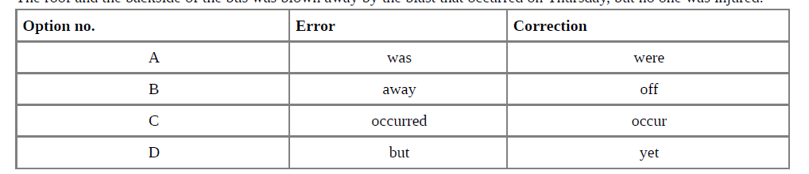

* 1. 5.On my friend's farm, they ________ an alarm clock because the cockerel ________ at five o'clock every morning without fail
  2. a) don't need / crows
  3. b) haven't needed / was crowing
  4. c) wont need / is crowing
  5. d) didn't need / will crow
  6. 6.Report the dialogue between Jitu and Nitu, by completing the sentence:
  7. Jitu: My crash-course batch is full as only a month is left for the final exams.
  8. Nitu: A drowning man will catch a straw.
  9. Jitu said that his crash-course batch was full as only a month was left for the final exams, to which Nitu said that________.

1. 7. Identify the error and supply the correction, for the following
2. A picture containing text, screenshot, line, font

   Description automatically generated

8.Elvis went to a shop to mend his watch. The watchmaker asked a few questions related to the watch. Report his question.

Did you buy this Swiss watch at my place?

9.Select the correct option to fill in the blank for the given line, from a health magazine.

You ________ eat to live, not live to eat

a) can

b) might

c) must

d) should

10. "I am leaving the city tomorrow," the lecturer said

.He said that ________ leaving the city ________.

a) he is, tomorrow

b) he was, the following day

c) he was, that day

d) I was, previous day

11.Identify the error in the given sentence, from a school magazine report and supply the correction. Critics have time and again points out that our education system tends to judge widely different students on single-line parameters, which is unfair. Use the given format for your response

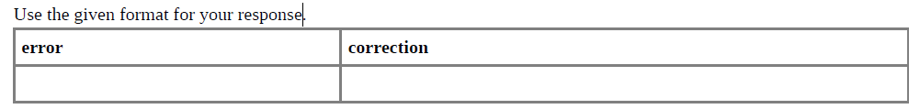

12.Fill in the blank by choosing the correct option, to complete the words of an Olympic champion. You ________ be tough enough to achieve your goal.

a) will

b) may

c) can

d) must

**SECTION B WRITING—Letter of Complaint**

1. You bought a refrigerator two months ago from Mohan Sales, Ashok Vihar, Bangalore. It has developed certain problems regarding its functioning. Write a letter of complaint to the Manager asking him for immediate repair / replacement of the same. You are Sachin/ Shashi , 61 Pratap Enclave , Bangalore.
2. Woodcutters Inc. could not deliver the furniture to Eureka Forbes in working condition. Write a letter of complaint with immediate effect to the Delivery Department, Woodcutters Inc. Janakpuri, Delhi

112233 to redress your grievances.

1. Beggars are causing a lot of nuisance in your city. Write a letter to the Municipal Commissioner requesting him/her to take suitable action in public interest, in about 120 words.